INDUSTRIAL SURVEYING

3

3

3

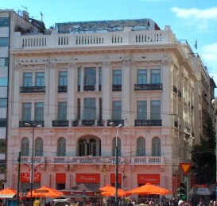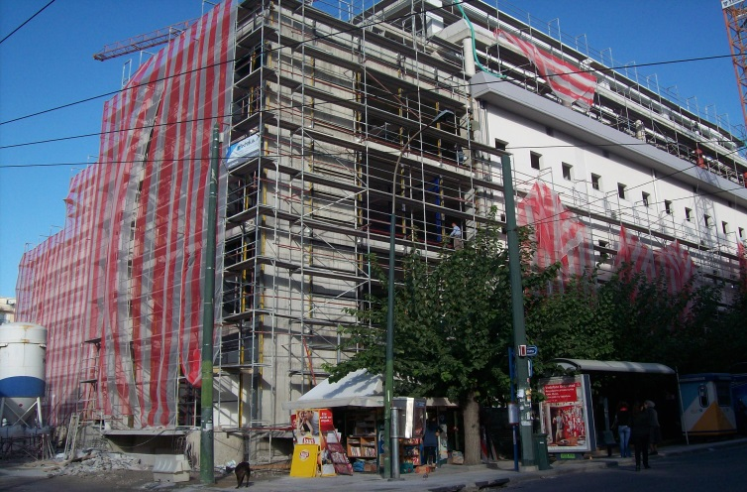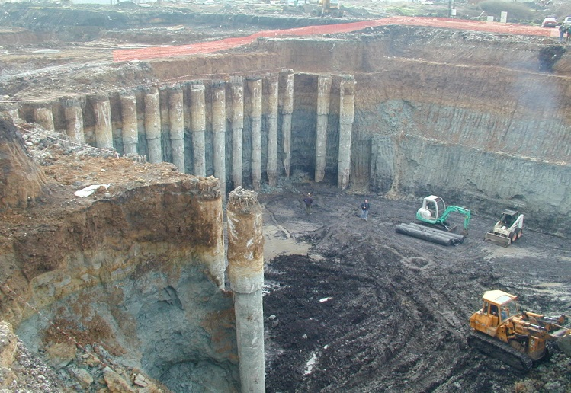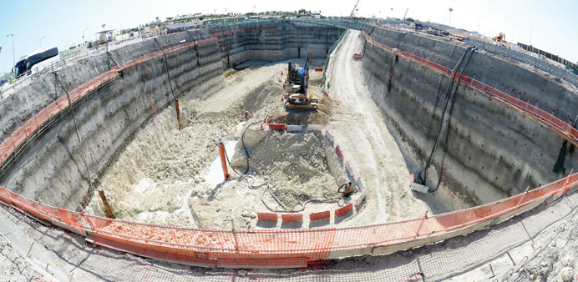

The system consists of a high accuracy networked robotic total stations and prisms located on the point of interest.

This system ensures valuable and timely monitoring of the displacements, providing high measurements density, simultaneous wireless transmission and entry of the results into the MDB system to ensure minimal time between their reading and their evaluation.

The measurements are taken with a series of automatic electronic total stations of high precision, which will record the displacement of reflecting prisms on the ground surface and on buildings.

The robotic total station are capable of carrying out automatic measurements, both at predetermined sequences and at any arbitrarily time and the maximum measurement range is in the accordance with the environmental conditions.

The total stations are remotely controlled by software and are capable of:

* Following a pre- programmed operation
* Allowing changes in the measurement regime to be implemented , including the measurement cycle
* Providing continuous data for one point.

The system allows the above changes to be made remotely via internet connections. The instruments are capable of self- seeking a point which has moved by at least 30mm without affecting the monitoring regime/ data return time adversely.

Public Store, Syntagma, Attica

WFGD UNIT at UNIT III of PPC S. A Megalopolis

3. AUTOMATED MOONITORING SYSTEM (AMS) OF REAL TIME TOTAL DISPALCEMENTS (3D)

Three dimensional displacement measurements (3D) are carried out within the Zone of influence in order to determine the movement on adjustment to be the project structures and buildings. Reflectors are installed in tunnels, structures, etc. and the measurements are made with high precision total stations by the method of free station.

The reference network of the points, which is to be used for 3D measurements, consists of reference points with permanent labelling at the locations outside the zone of influence of the works or at locations remote to the excavation faces. The reference network will be checked at regular time intervals. All the measurements are corrected by the impact of the pressure and temperature diffractions. The precision of the measurements of total displacements is ± 2mm.

Karouzos Station, Larisis Station

Gold Lines, Doha Qatar

2. CONVECTIONAL THREE- DIMENSIONAL TOPOGRAPHICAL MEASURING SYSTEMS

4

Surveying Precision

DEFORMATION MONITORING

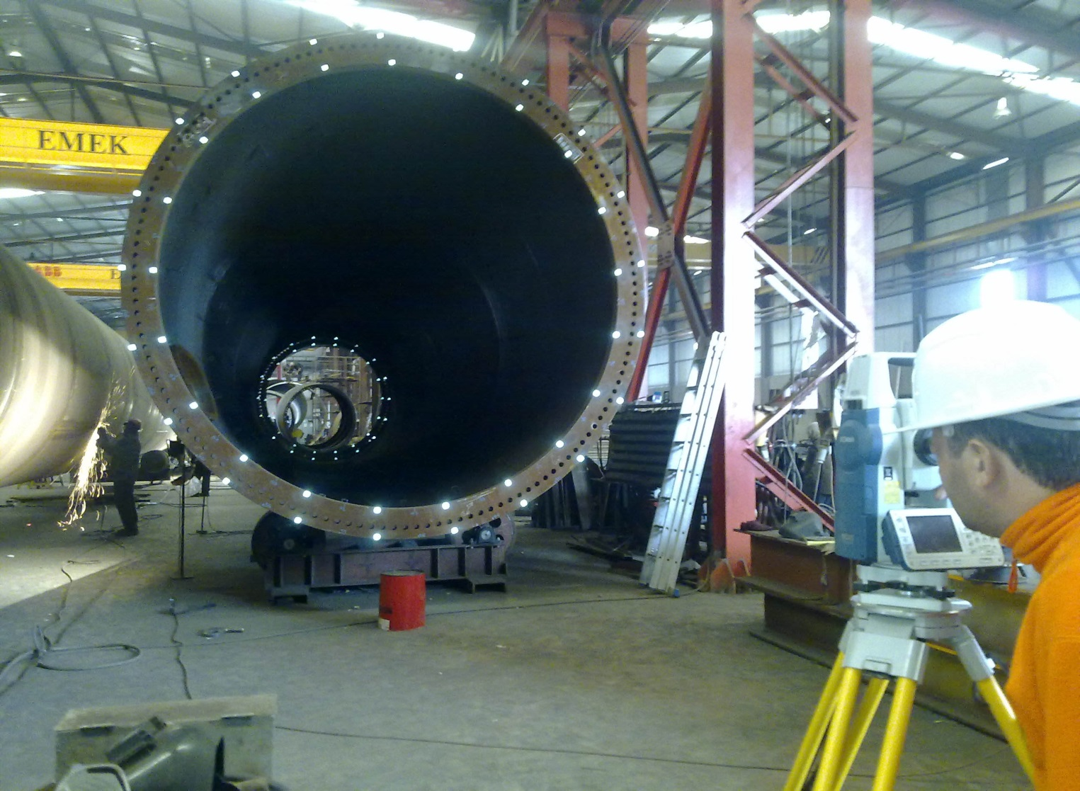

3

High Pressure Natural Gas and Regulating Station, Tema, Ghana

3

3

INDUSTRIAL SURVEYING

INDUSTRIAL SURVEYING

3

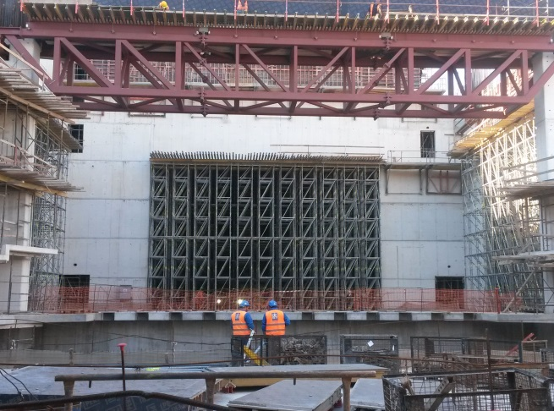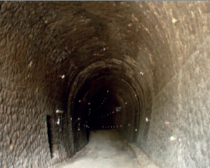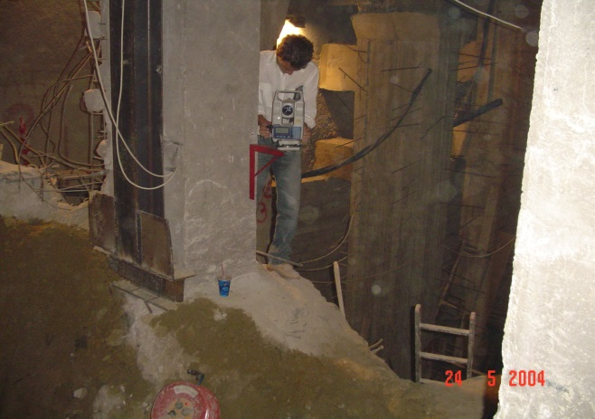

Opera Auditorium at SNFCC

Karouzos Station Shopping Center, Attica

5

Ag. Stefanos, rail tunnel

PROJECTS

* Karouzos Shopping Center at Larisis Train Station, Attica. Deformation monitoring on piles and on adjacent buildings structures during earthworks periods.
* New Office Complex Building of Anangel Shipping Company, Kallithea, Attica. Deformation monitoring on piles and on adjacent buildings structures during earthworks periods.
* 6-floor Underground Parking Building, Kifisia, Attica. Deformation monitoring on piles and on adjacent buildings structures during earthworks periods.
* Rea Maternity Hospital, Piraeus, Attica. Deformation monitoring on piles and on adjacent buildings structures during earthworks periods.
* ”Gold line Underground” , Doha, Qatar. Deformation Monitoring across the Zone of influence on buildings and structures.

1. m).

* Public Store, Syntagma, Attica. Deformation Monitoring on erected building during foundation expansion.
* Tsakona Bridge, Kalamata. Automated monitoring system(AMS) install for deformation monitoring on frame bases during erection period.
* Minion Multistore, Syntagma, Attica. Deformation Monitoring on erected building during foundation expansion.

www.aksm.gr

Minion, Multistore, Attica

5

APPLICATIONS

In particular, some of the application of this methodology have been used in :

* Dams
* Roads
* Tunnels
* Bridges and overpasses
* Multistory and historical buildings
* Foundations
* Mining- exploitation
* Landsides and sloping
* Earthquake- prone regions

DEFORMATION MONITORING

5

**SURVEYING PRECISION**

mail: info@aksm.gr